**Samuel Homer**

**11/21/2018**

**Opening Form (page 1/14)**

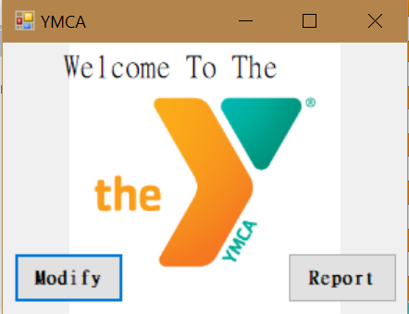

Public Class Main

Private Sub btnModify_Click(sender As Object, e As EventArgs) Handles btnModify.Click

Dim modify_form As New Find

modify_form.ShowDialog()

End Sub

Private Sub btnReport_Click(sender As Object, e As EventArgs) Handles btnReport.Click

Dim display_form As New Report

display_form.ShowDialog()

End Sub

End Class

**Find Form**

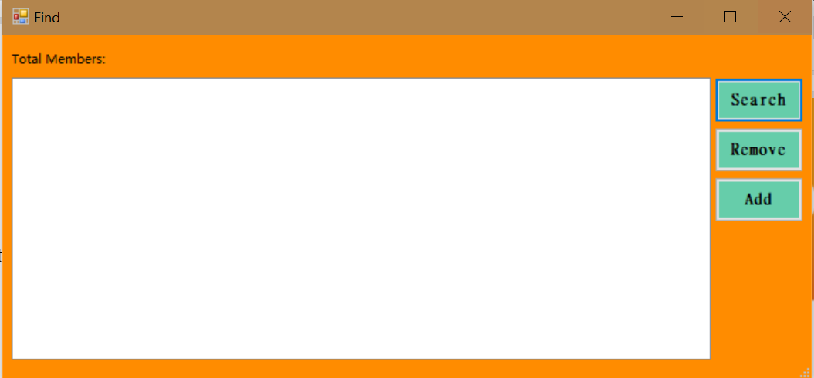

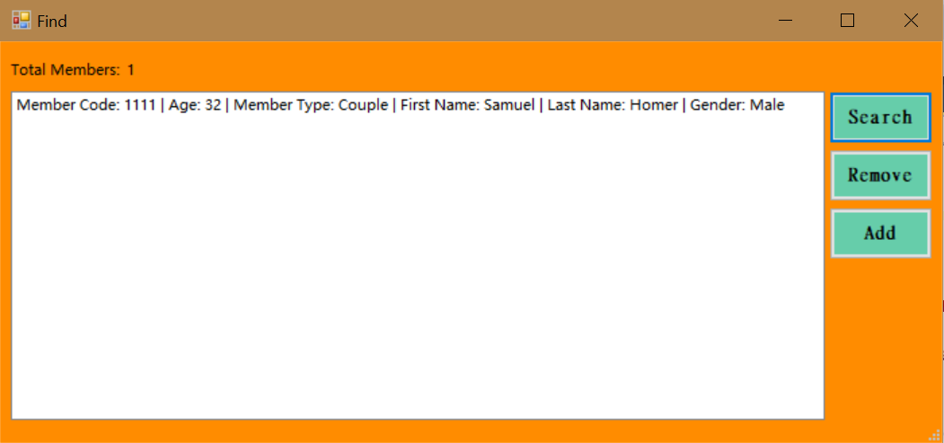

Public Class Find

Private Sub btnAddMemberForm_Click(sender As Object, e As EventArgs) Handles btnAddMemberForm.Click

Dim add_form As New AddForm

add_form.ShowDialog()

End Sub

Private Sub btnDisplay_Click(sender As Object, e As EventArgs) Handles btnDisplay.Click

lstSearchAll.Items.Clear()

If count > 0 Then

For i = 0 To count - 1

lstSearchAll.Items.Add("Member Code: " + member_code_array(i).ToString + " | " + "Age: " + age_array(i).ToString + " | " + "Member Type: " + member_type_array(i) + " | " + "First Name: " + first_name_array(i) + " | " + "Last Name: " + last_name_array(i) + " | " + "Gender: " + gender_array(i))

Next

lblCount.Text = count.ToString

Else

lblCount.Text = ("0 items").ToString

End If

End Sub

Private Sub btnRemove_Click(sender As Object, e As EventArgs) Handles btnRemove.Click

For index As Integer = lstSearchAll.SelectedItems.Count - 1 To 0 Step -1

If index >= 0 Then

lstSearchAll.Items.Remove(lstSearchAll.SelectedItems(index))

count -= 1

lblCount.Text = count.ToString

Else

lblCount.Text = "Please select an option"

End If

Next index

End Sub

End Class

**Add Form**

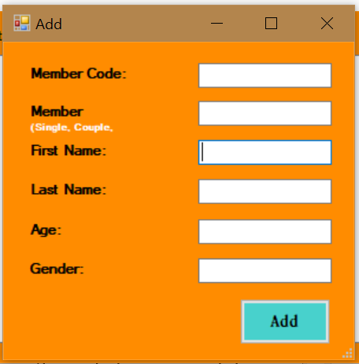

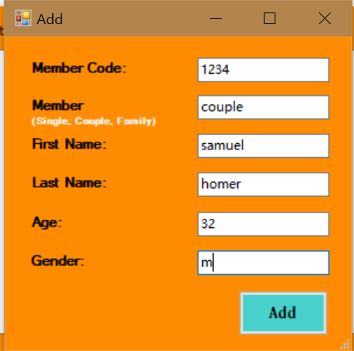

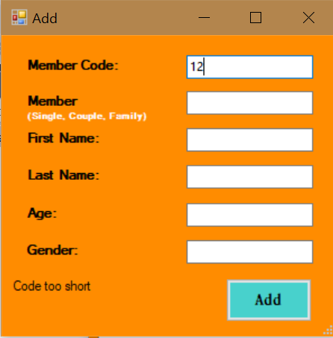

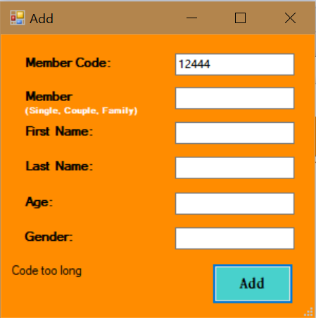

Public Class AddForm

Private Sub btnAddMember_Click(sender As Object, e As EventArgs) Handles btnAddMember.Click

If Len(txtCode.Text) > 4 Then

lblDisplay.Text = "Code too long".ToString

ElseIf Len(txtCode.Text) < 4 Then

lblDisplay.Text = "Code too short".ToString

Else

Try

member_code_array(count) = CInt(txtCode.Text)

If String.IsNullOrEmpty(txtMemberType.Text) Or IsNumeric(txtMemberType.Text) Then

lblDisplay.Text = "Please enter member type as Single, Couple, or Family"

Else

Try

member_type_array(count) = CStr(txtMemberType.Text)

If txtMemberType.Text.Equals("single", StringComparison.CurrentCultureIgnoreCase) Then

txtMemberType.Text = "Single"

ElseIf txtMemberType.Text.Equals("couple", StringComparison.CurrentCultureIgnoreCase) Then

txtMemberType.Text = "Couple"

ElseIf txtMemberType.Text.Equals("family", StringComparison.CurrentCultureIgnoreCase) Then

txtMemberType.Text = "Family"

End If

member_type_array(count) = CStr(txtMemberType.Text)

If String.IsNullOrEmpty(txtFirst.Text) Or IsNumeric(txtFirst.Text) Then

lblDisplay.Text = "Please enter first name"

Else

If txtFirst.TextLength > 1 Then

first_name_array(count) = CStr(txtFirst.Text.Substring(0, 1).ToUpper + txtFirst.Text.Substring(1))

ElseIf txtFirst.TextLength = 1 Then

first_name_array(count) = txtFirst.Text.ToUpper()

End If

If String.IsNullOrEmpty(txtLast.Text) Or IsNumeric(txtLast.Text) Then

lblDisplay.Text = "Please enter last name"

Else

If txtLast.TextLength > 1 Then

last_name_array(count) = CStr(txtLast.Text.Substring(0, 1).ToUpper + txtLast.Text.Substring(1))

ElseIf txtFirst.TextLength = 1 Then

last_name_array(count) = txtLast.Text.ToUpper()

End If

Try

age_array(count) = CInt(txtAge1.Text)

If String.IsNullOrEmpty(txtGender.Text) Or IsNumeric(txtGender.Text) Then

lblDisplay.Text = "Please enter gender"

Else

Try

gender_array(count) = CStr(txtGender.Text)

If txtGender.Text.Equals("m", StringComparison.CurrentCultureIgnoreCase) Or txtGender.Text.Equals("male", StringComparison.CurrentCultureIgnoreCase) Then

gender_array(count) = "Male"

ElseIf txtGender.Text.Equals("f", StringComparison.CurrentCultureIgnoreCase) Or txtGender.Text.Equals("female", StringComparison.CurrentCultureIgnoreCase) Then

gender_array(count) = "Female"

End If

count += 1

Me.Hide()

Catch

lblDisplay.Text = "Please enter gender "

End Try

End If

Catch

lblDisplay.Text = "Please enter numeric age"

End Try

End If

End If

Catch

lblDisplay.Text = "Please enter Single, Couple, or Family"

End Try

End If

Catch

lblDisplay.Text = "Please enter 4 digit code"

End Try

End If

End Sub

End Class

**Report Form**

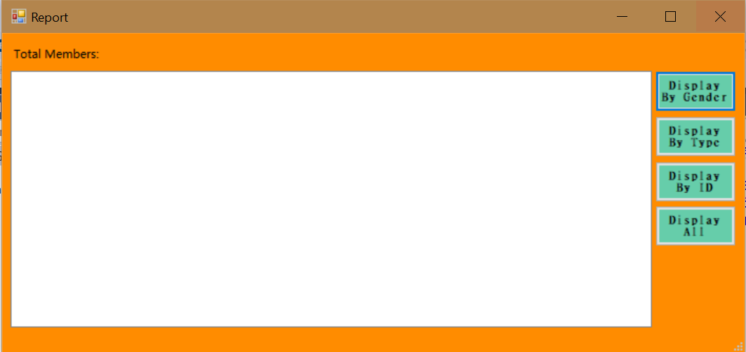

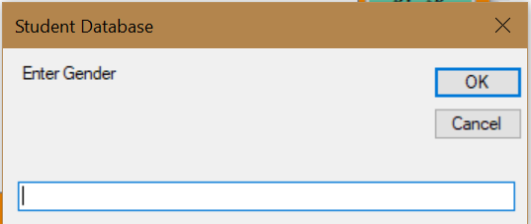

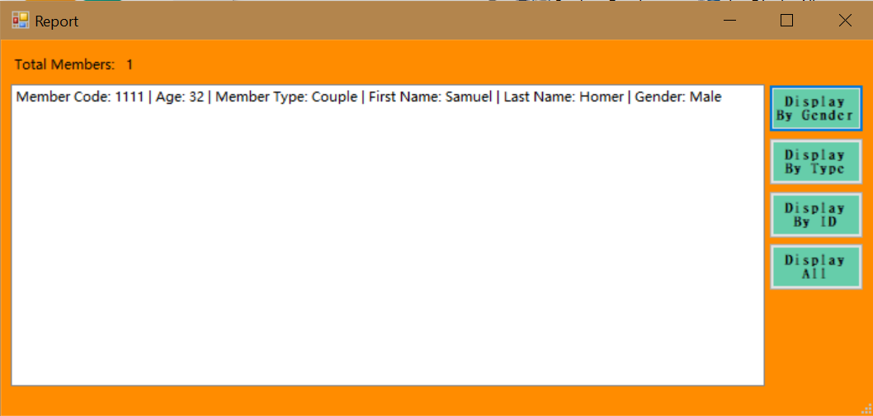

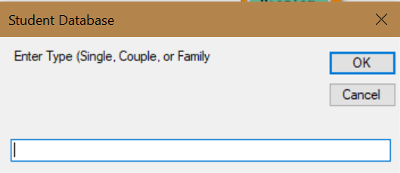

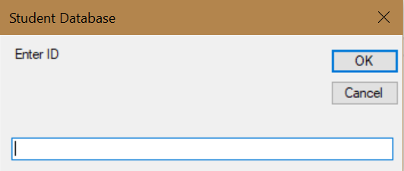

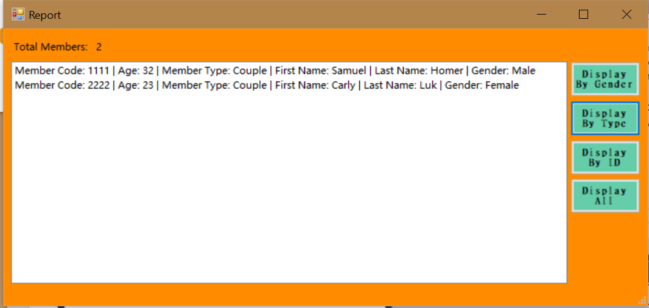

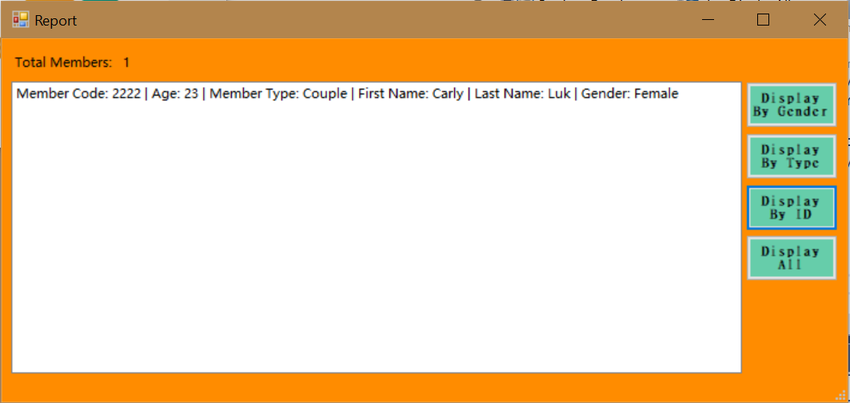

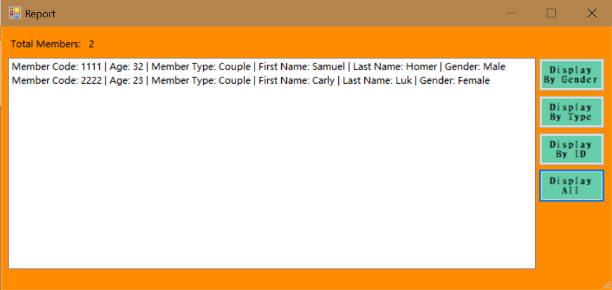

Class Report

Private Sub btnDisplayAll_Click(sender As Object, e As EventArgs) Handles btnDisplayAll.Click

lstDisplayAll.Items.Clear()

If count > 0 Then

For i = 0 To count - 1

lstDisplayAll.Items.Add("Member Code: " + member_code_array(i).ToString + " | " + "Age: " + age_array(i).ToString + " | " + "Member Type: " + member_type_array(i) + " | " + "First Name: " + first_name_array(i) + " | " + "Last Name: " + last_name_array(i) + " | " + "Gender: " + gender_array(i))

Next

lblCount.Text = count.ToString

Else

lblCount.Text = ("No Results")

End If

End Sub

Private Sub btnSearchGender_Click(sender As Object, e As EventArgs) Handles btnSearchGender.Click

Dim searchgender As String

searchgender = CStr(InputBox("Enter Gender"))

If searchgender.Equals("m", StringComparison.CurrentCultureIgnoreCase) Or searchgender.Equals("male", StringComparison.CurrentCultureIgnoreCase) Then

searchgender = "male"

ElseIf searchgender.Equals("f", StringComparison.CurrentCultureIgnoreCase) Or searchgender.Equals("female", StringComparison.CurrentCultureIgnoreCase) Then

searchgender = "female"

End If

lstDisplayAll.Items.Clear()

If count > 0 Then

Dim gender_count As Integer = 0

For i = 0 To count - 1

Try

If gender_array(i).Equals(searchgender, StringComparison.CurrentCultureIgnoreCase) Or gender_array(i).Equals(searchgender, StringComparison.CurrentCultureIgnoreCase) Then

lstDisplayAll.Items.Add("Member Code: " + member_code_array(i).ToString + " | " + "Age: " + age_array(i).ToString + " | " + "Member Type: " + member_type_array(i) + " | " + "First Name: " + first_name_array(i) + " | " + "Last Name: " + last_name_array(i) + " | " + "Gender: " + gender_array(i))

gender_count += 1

Else

lblCount.Text = ("No Results")

End If

Catch

lblCount.Text = ("No Results")

End Try

Next

lblCount.Text = gender_count.ToString

Else

lblCount.Text = ("No Results")

End If

End Sub

Private Sub btnSearchType_Click(sender As Object, e As EventArgs) Handles btnSearchType.Click

Dim searchtype As String

searchtype = CStr(InputBox("Enter Type (Single, Couple, or Family"))

If searchtype.Equals("single", StringComparison.CurrentCultureIgnoreCase) Then

searchtype = "Single"

ElseIf searchtype.Equals("couple", StringComparison.CurrentCultureIgnoreCase) Then

searchtype = "Couple"

ElseIf searchtype.Equals("family", StringComparison.CurrentCultureIgnoreCase) Then

searchtype = "Family"

End If

lstDisplayAll.Items.Clear()

If count > 0 Then

Dim search_type_count As Integer = 0

For i = 0 To count - 1

Try

If member_type_array(i).Equals(searchtype, StringComparison.CurrentCultureIgnoreCase) Then

lstDisplayAll.Items.Add("Member Code: " + member_code_array(i).ToString + " | " + "Age: " + age_array(i).ToString + " | " + "Member Type: " + member_type_array(i) + " | " + "First Name: " + first_name_array(i) + " | " + "Last Name: " + last_name_array(i) + " | " + "Gender: " + gender_array(i))

search_type_count += 1

Else

lblCount.Text = ("No Results")

End If

Catch

lblCount.Text = ("No Results")

End Try

Next

lblCount.Text = search_type_count.ToString

Else

lblCount.Text = ("No Results")

End If

End Sub

Private Sub btnSearchID_Click(sender As Object, e As EventArgs) Handles btnSearchID.Click

Dim searchID As Integer

Try

searchID = CInt(InputBox("Enter ID"))

Catch

lblCount.Text = ("Please enter numeric ID")

End Try

lstDisplayAll.Items.Clear()

Dim search_ID_count As Integer = 0

If count > 0 Then

For i = 0 To count - 1

Try

If member_code_array(i).Equals(searchID) Then

lstDisplayAll.Items.Add("Member Code: " + member_code_array(i).ToString + " | " + "Age: " + age_array(i).ToString + " | " + "Member Type: " + member_type_array(i) + " | " + "First Name: " + first_name_array(i) + " | " + "Last Name: " + last_name_array(i) + " | " + "Gender: " + gender_array(i))

search_ID_count += 1

Else

lblCount.Text = ("No Results")

End If

Catch

lblCount.Text = ("No Results")

End Try

Next

lblCount.Text = search_ID_count.ToString

Else

lblCount.Text = ("No Results")

End If

End Sub

End Class

**Module**

Module Members

Const intMax As Integer = 100

Public member_code_array(intMax) As Integer

Public age_array(intMax) As Integer

Public member_type_array(intMax) As String

Public first_name_array(intMax) As String

Public last_name_array(intMax) As String

Public gender_array(intMax) As String

Public new_array_age(intMax) As Integer

Public count As Integer = 0

Public i As Integer

End Module